**UE17CS402:**

**SOFTWARE ENGINEERING (4-0-0-0-4)**

**UNIT 1**

**Question and Answers**

1. **Discuss a generic SDLC**

**Soln.**

SDLC or Software development Lifecycle is the set of steps or phases with a focus for each step, which if followed would support building of a software product with a higher probability of being repeatable, meeting with the expectation of the customers, meeting the quality constraints and would be deterministic and effective.

A generic lifecycle for development of a software product would include the steps, the outcomes for each of the phases. A simple waterfall kind of lifecycle could be

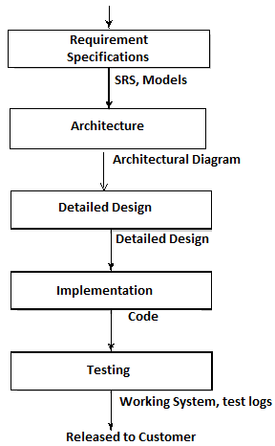

Discuss each phase e.g.  
**Requirement Specifications Phase:**

Entry criteria: Feasibility Report available and approved for development  
Focus: Requirements to be gathered and specified  
Activities: Elicitation, analysis, specification and verification  
Outcome: Software requirement Specification

**Architecture Phase:**

…..

1. **Discuss the SCRUM model from the perspective of people and their roles**

**Soln:**

SCRUM model is a software development lifecycle model based on the Agile principles. The following are different roles for people.

**Scrum teams:**

The total people who are involved with the software development is divided into Scrum teams.

* + made up of contributors to the deliverable
  + responsible for delivering shippable increments
  + Self-organized (so no manager)
  + Cross Functional thus will have people with different specialization from architects, implementors, testers, build engineers, documentation specialists etc.

**Scrum Master**

* + He is the facilitator
  + Who removes impediments for the progress of the project.
  + Facilitates meetings for Scrum team
  + Ensures team adheres to scrum theory and practices

**Scrum Master**

* + He is the voice or representative of the stakeholder/team
  + Create/manages and Product Backlog

1. **What is requirements elicitation?**

**Soln:**

Requirements elicitation Is a process of working proactively with all stakeholders gathering their needs, articulating their problem, identify and negotiate potential conflicts thereby establishing a clear scope and boundary for a project.

It can also be described as a process of ensuring that the stakeholders have been identified and they have been given an opportunity to explain their problem and needs and describe what they would like the new system to do.

1. Discuss the Pareto analysis? Why is it relevant in requirement analysis process?

Soln:

All projects and product typically have constraints in terms of budget of time (schedule), money, in terms of people resources, technologies which can be used etc. Most projects and products also will have requirements which are significantly larger than what can be achieved in the constraints where they have to be built in.

Pareto analysis is a mechanism where we look to identify the critical requirements first by prioritizing them so that they can be implemented as a base requirement. Pareto analysis helps in Identifying the critical few requirements. The Parto’s law indicates that in any environment there are only a very few of the contributors which impact 80% of what is needed. The rest of the contributors contribute to the rest 20% of what is needed. This is called 80:20 which are trivial many and the vital few. So this is used for ensuring the relevant or smaller subset of requirements are addressed and prioritized higher than the many.